Question 01.

package q01;

public class **Child** extends **Parent** {

void display() {

System.out.println("This is child class");

}

}

package q01;

public class **Parent** {

void show() {

System.out.println("This is parent class");

}

}

package q01;

public class **Main** {

public static void main(String[] args) {

Parent parentObject = new Parent();

Child childObject = new Child();

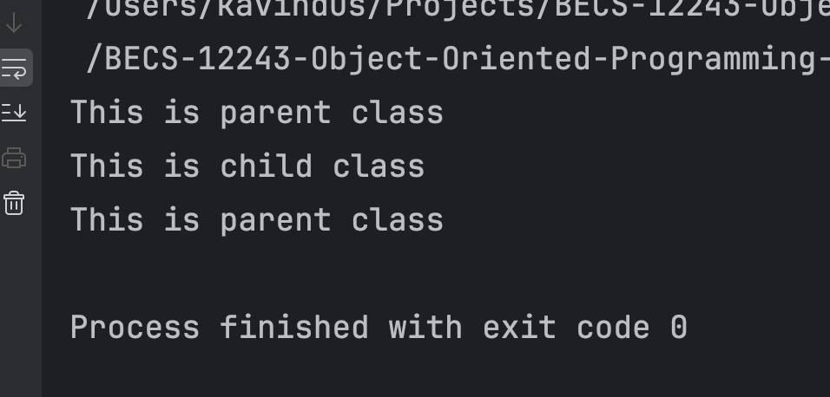 parentObject.show();

childObject.display();

childObject.show();

// parentObject.display();

}

}

We cannot called child class's method using a parent class object because a parent class doesn't know about methods specific to its child classes.

Question 02.

package q02;

public class **Main** {

public static void main(String[] args) {

Employee emp = new Employee("Wasanth Vittachchi", 25, "7266776666",

"1/23 Sandamadulla, Kandy", 59000, "Software Development");

Manager mgr = new Manager("Janaka Sumith", 35, "2336632323",

"45/6 Ampara, Town", 83000, "IT");

System.out.println("Employee Salary:");

emp.printSalary();

System.out.println("\nManager Salary:");

mgr.printSalary();

System.out.println("\nEmployee Details:");

emp.printDetails();

System.out.println("\nManager Details:");

mgr.printDetails();

}

}

package q02;

public class **Employee** extends **Member** {

private String specialization;

public Employee(String name, int age, String phoneNumber, String address,

double salary, String specialization) {

super(name, age, phoneNumber, address, salary);

this.specialization = specialization;

}

public void printDetails() {

super.printDetails();

System.out.println("Specialization: " + specialization);

}

}

package q02;

public class **Member** {

private String name;

private int age;

private String phoneNumber;

private String address;

private double salary;

public Member(String name, int age, String phoneNumber, String address, double salary) {

this.name = name;

this.age = age;

this.phoneNumber = phoneNumber;

this.address = address;

this.salary = salary;

}

public void printSalary() {

System.out.println("Salary: " + salary);

}

public void printDetails() {

System.out.println("Name: " + name);

System.out.println("Age: " + age);

System.out.println("Phone Number: " + phoneNumber);

System.out.println("Address: " + address);

System.out.println("Salary: " + salary);

}

}

package q02;

public class **Manager** extends **Member** {

private String department;

public Manager(String name, int age, String phoneNumber, String address,

double salary, String department) {

super(name, age, phoneNumber, address, salary);

this.department = department;

}

public void printDetails() {

super.printDetails();

System.out.println("Department: " + department);

}

}

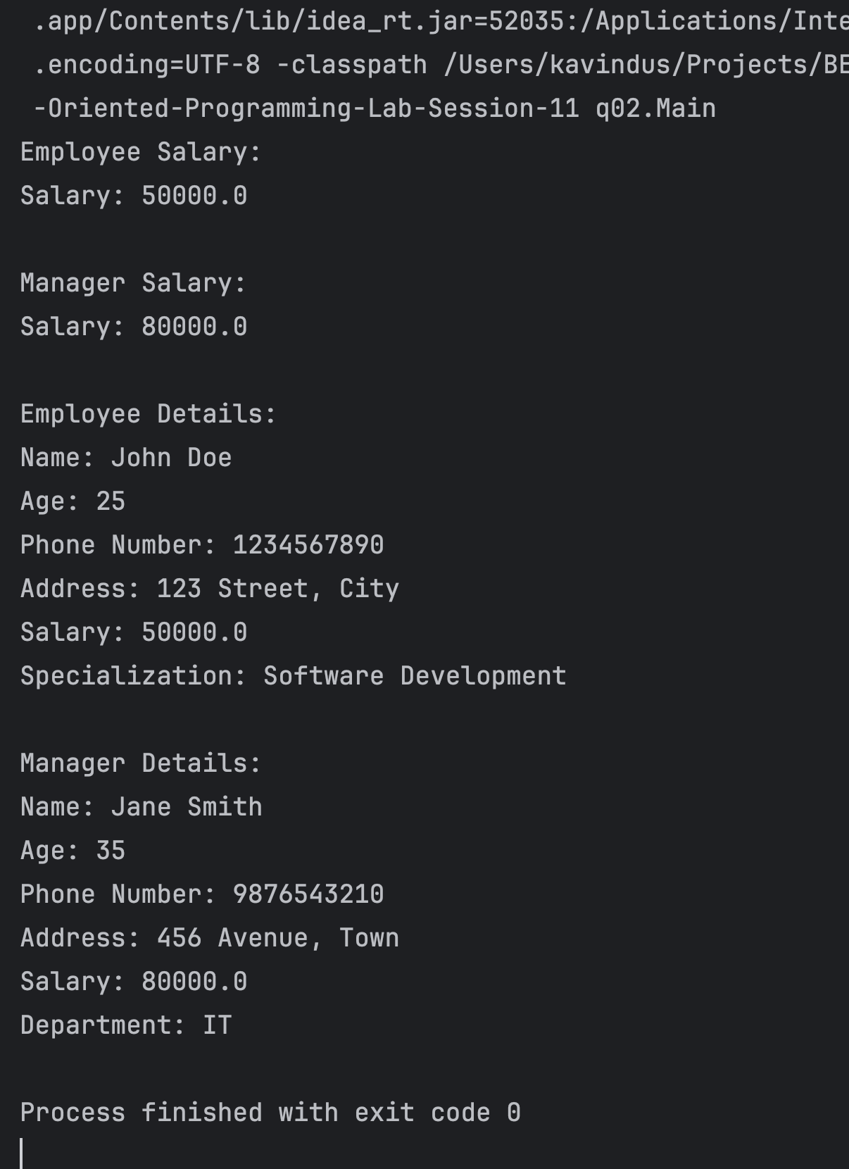

Question 03.

package q03;

public class **Instructor** extends **User** {

private String[] teachingCourses;

public Instructor(String name, String userID, String[] teachingCourses) {

super(name, userID);

this.teachingCourses = teachingCourses;

}

public void assignGrades(String studentName, String grade) {

System.out.println("Instructor " + name + " assigned grade " + grade + " to " + studentName);

}

}

package q03;

public class **Student** extends **User** {

private String[] enrolledCourses;

public Student(String name, String userID, String[] enrolledCourses) {

super(name, userID);

this.enrolledCourses = enrolledCourses;

}

public void viewCourses() {

System.out.println("Enrolled Courses: " + String.join(", ", enrolledCourses));

}

}

package q03;

public class **User** {

protected String name;

protected String userID;

public User(String name, String userID) {

this.name = name;

this.userID = userID;

}

public void login() {

System.out.println("User " + name + " with ID " + userID + " has logged in.");

}

}

package q03;

public class **Main** {

public static void main(String[] args) {

String[] studentCourses = {"C++", "Web Development", "Data Structures"};

Student student = new Student("Janitha Dasun", "S001", studentCourses);

String[] instructorCourses = {"Python 101", "Advanced Python"};

Instructor instructor = new Instructor("Dr. Sujeewa", "I001", instructorCourses);

student.login();

instructor.login();

student.viewCourses();

instructor.assignGrades("Janitha Dasun", "A");

//cmt-01 student.assignGrades("Test Student", "B");

// System.out.println("Student cannot access instructor methods");

//cmt-02 instructor.viewCourses();

//System.out.println("Instructor cannot access student methods");

}

}

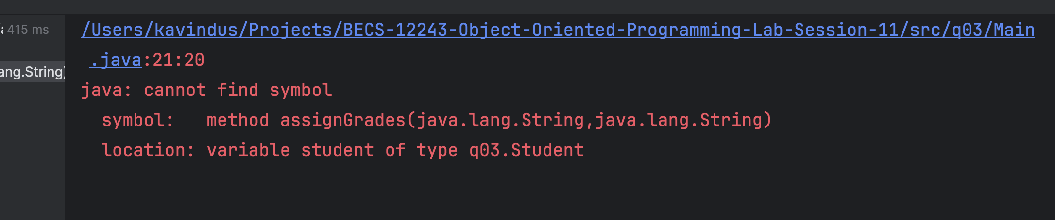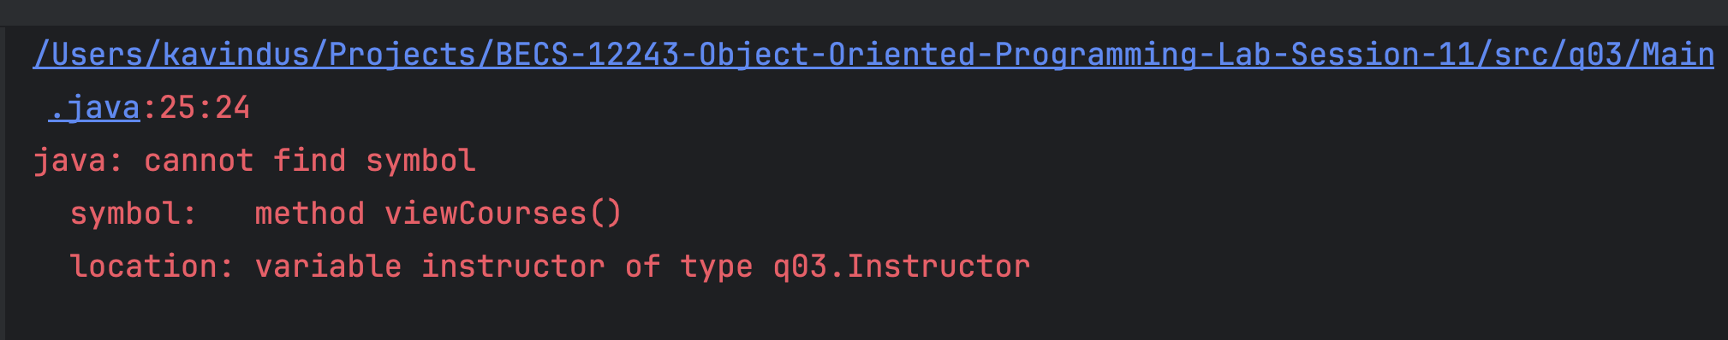

If I uncomment above cmt-01 and cmt-02, The above error has occur and Doesn’t compile. We cannot access different object’s method through another instance of another class.

Question 04.

package q04;

public class **BankingSystem** {

public static void main(String[] args) {

SavingsAccount savingsAccount01 = new SavingsAccount("SAV001","Sumana Galappaththi",32500);

CurrentAccount currentAccount01 = new CurrentAccount("CURR001","Ajith Muthukumarana",65000);

currentAccount01.setCreditLimit(9500);

currentAccount01.displayAccountDetails();

savingsAccount01.withdraw(100);

savingsAccount01.displayAccountDetails();

currentAccount01.withdraw(100);

currentAccount01.displayAccountDetails();

savingsAccount01.deposit(6500);

savingsAccount01.displayAccountDetails();

currentAccount01.deposit(7500);

currentAccount01.displayAccountDetails();

savingsAccount01.applyInterest();

savingsAccount01.displayAccountDetails();

currentAccount01.withdraw(5000);

currentAccount01.displayAccountDetails();

currentAccount01.withdraw(35000);

currentAccount01.displayAccountDetails();

}

}

package q04;

public class **CurrentAccount** extends **Account**{

double creditLimit ;

public CurrentAccount(String accountNumber, String accountHolderName, double balance) {

super(accountNumber, accountHolderName, balance);

}

public void setCreditLimit(double creditLimit) {

this.creditLimit = creditLimit;

}

public void withdraw(double amount){

if (amount<=creditLimit){

System.out.println("Withrawn Successfully "+amount);

super.balance-=amount;

} else {

System.out.println("Credit Ammount Exceded");

}

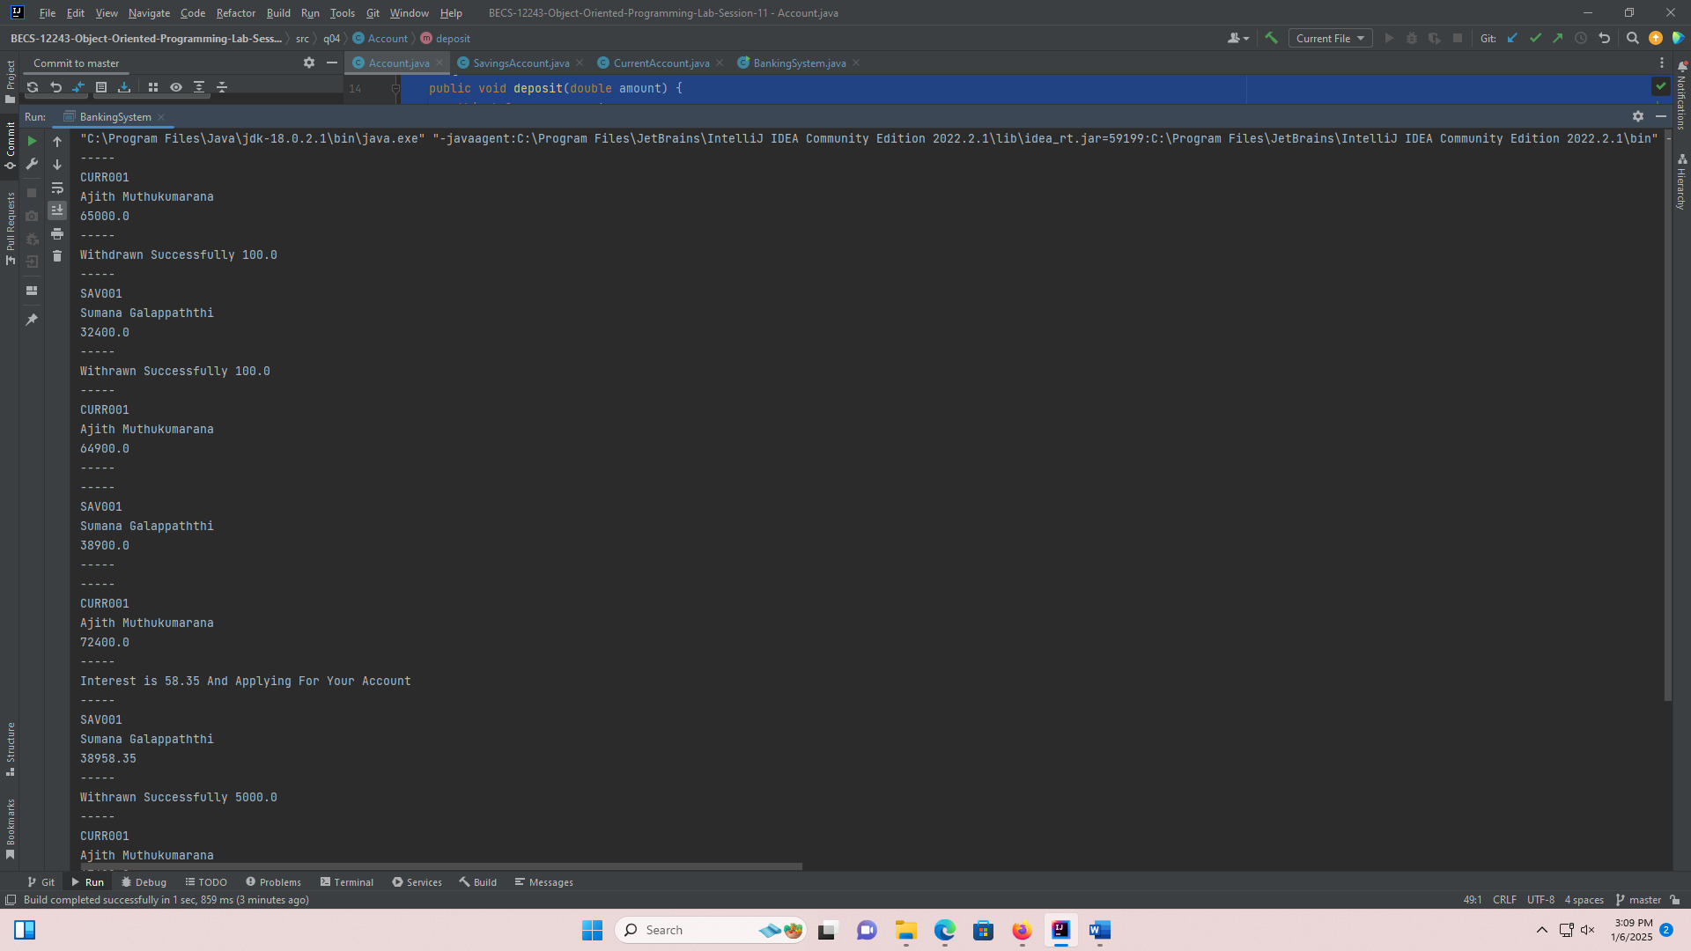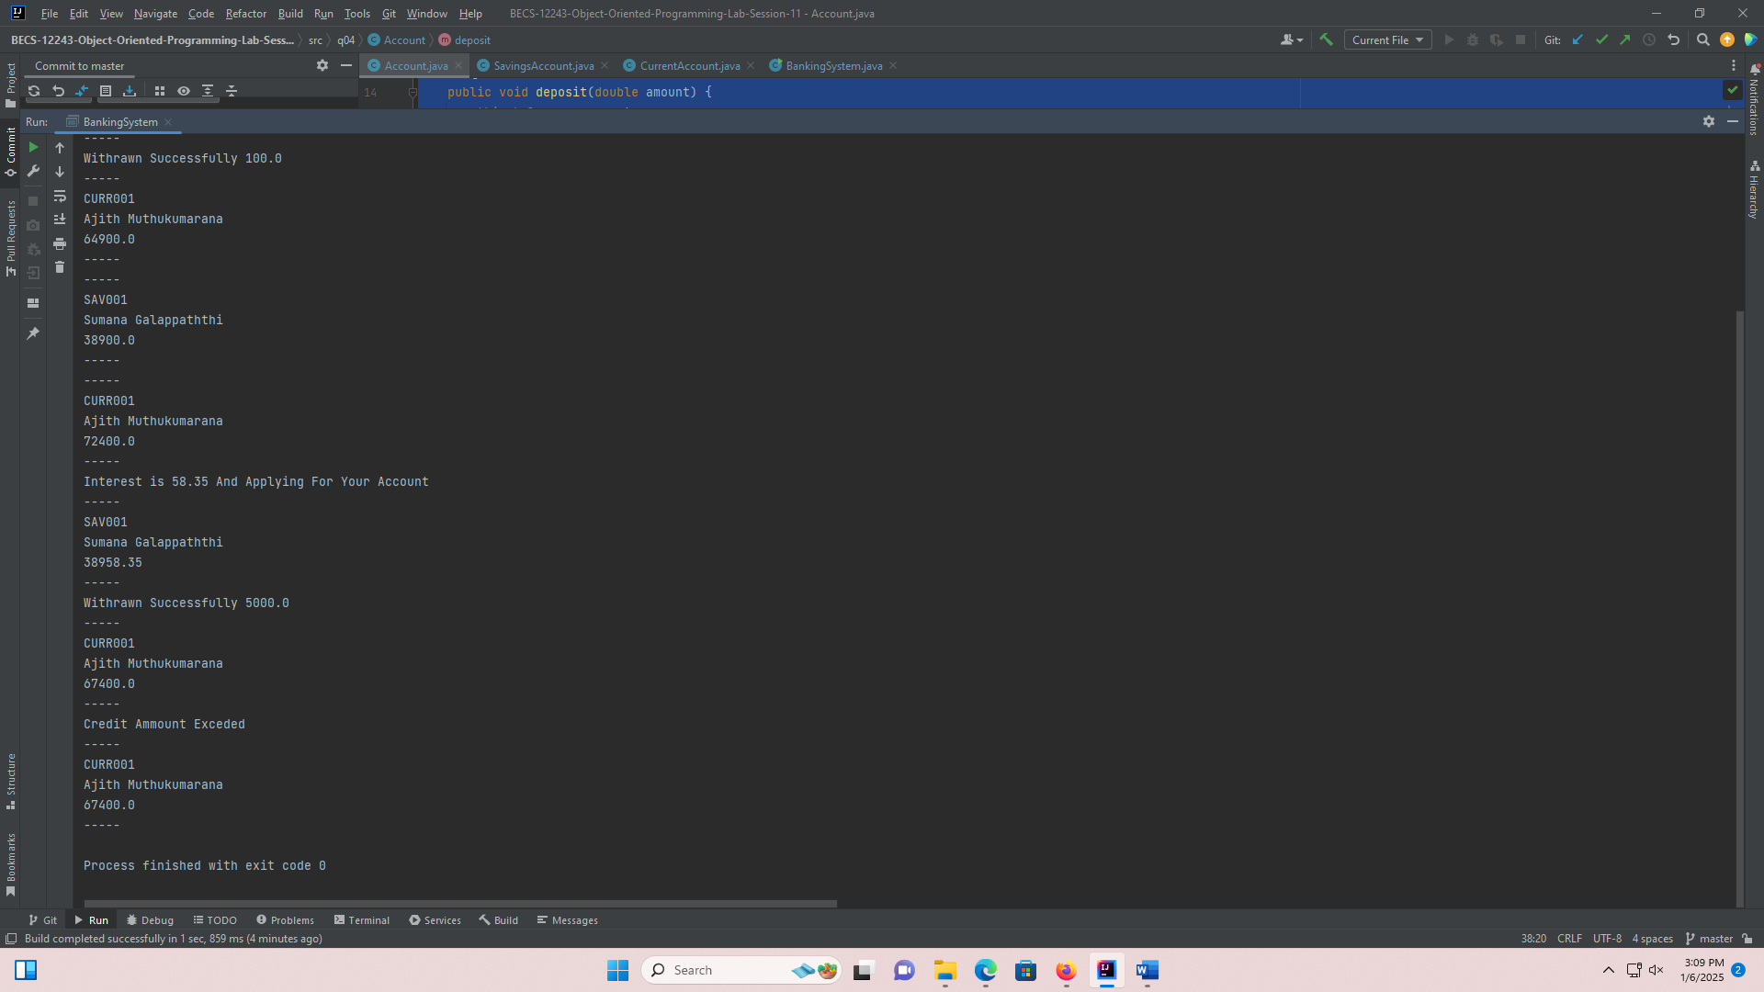 }

}

package q04;

public class **SavingsAccount** extends **Account** {

double interestRate = 0.15;

public SavingsAccount(String accountNumber, String accountHolderName, double balance) {

super(accountNumber, accountHolderName, balance);

}

public void withdraw(double amount){

if (super.balance >=0){

System.out.println("Withdrawn Successfully "+amount);

super.balance -= amount;

} else {

System.out.println("Insufficient Balance");

}

}

public void applyInterest(){

double Interest = balance * interestRate / 100;

System.out.println("Interest is "+Interest+ " And Applying For Your Account");

super.balance += Interest;

}

}

package q04;

public class **Account** {

protected String accountNumber;

protected String accountHolderName;

protected double balance;

public Account(String accountNumber, String accountHolderName, double balance) {

this.accountNumber = accountNumber;

this.accountHolderName = accountHolderName;

this.balance = balance;

}

public void deposit(double amount) {

this.balance +=amount;

}

public void displayAccountDetails() {

System.out.println("-----");

System.out.println(accountNumber);

System.out.println(accountHolderName);

System.out.println(balance);

System.out.println("-----");

}

}

Question 05.

package q05;

public class **Calculator** {

public static void main(String[] args) {

Addition add = new Addition();

Subtraction sub = new Subtraction();

Division div = new Division();

System.out.println(add.Addition(5, 7));

System.out.println(add.Addition(5.0, 7));

System.out.println(add.Addition(5, 7.0));

System.out.println(add.Addition(5.0, 7.0));

System.out.println(sub.Subtraction(95,15.5));

System.out.println(div.Division(5,0));

System.out.println(div.Division(15,0.5));

}

}

package q05;

public class **Subtraction** {

public int Subtraction(int a, int b) {

return a - b;

}

public double Subtraction(double a, double b) {

return a - b;

}

public double Subtraction(int a, double b) {

return a - b;

}

public double Subtraction(double a, int b) {

return a - b; }

}

package q05;

public class **Addition** {

public int Addition(int a, int b) {

return a + b;

}

public double Addition(double a, double b) {

return a + b;

}

public double Addition(int a, double b) {

return a + b;

}

public double Addition(double a, int b) {

return a + b;

}

}

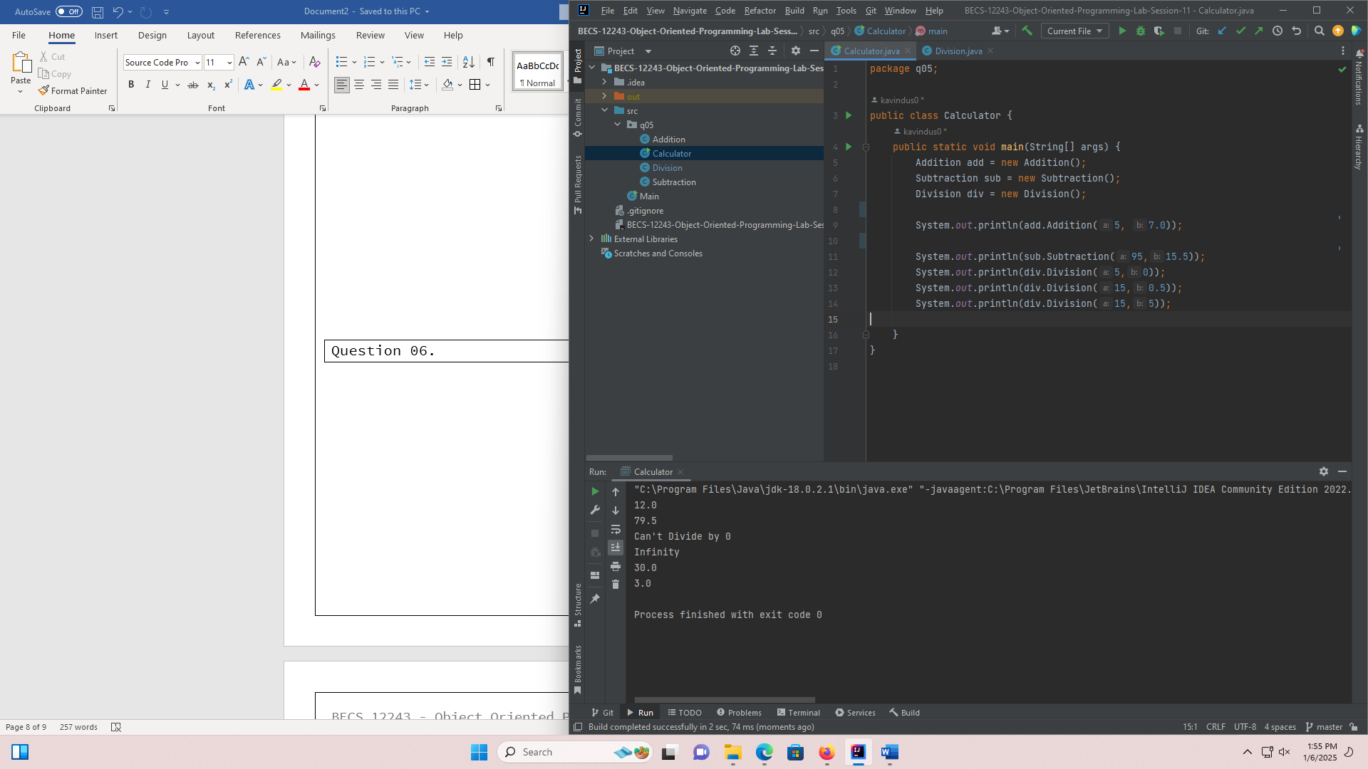

package q05;

public class **Division** {

public double Division(int a, int b) {

if (b==0){

System.out.println("Can't Divide by 0");

} else

return (double)a / b;

}

public double Division(double a, double b) {

if (b==0){

System.out.println("Can't Divide by 0");

} else

return a / b;

}

public double Division(int a, double b) {

if (b==0){

System.out.println("Can't Divide by 0");

}else

return a / b;

}

public double Division(double a, int b) {

if (b==0){

System.out.println("Can't Divide by 0");

}else

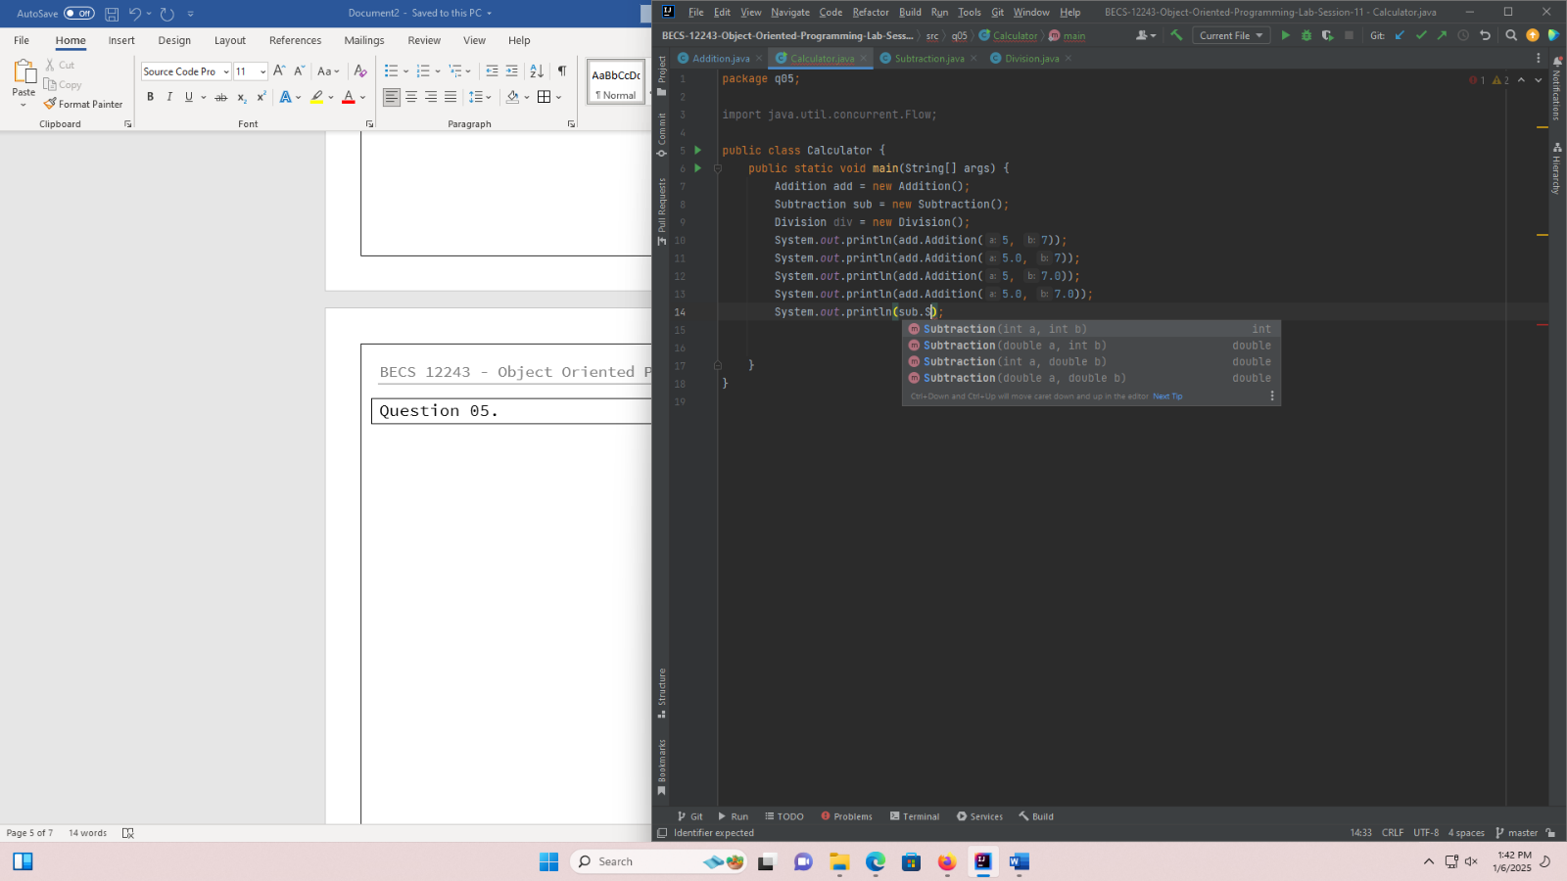 return a / b;

}

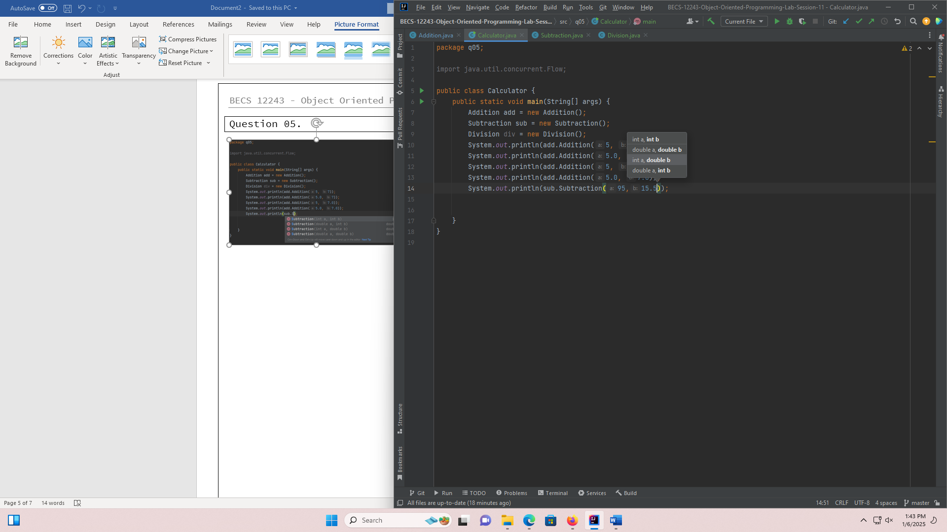}

Question 06.

package q06;

public class **StringManipulator** {

public static void main(String[] args) {

StringManipulator str = new StringManipulator();

System.out.println(str.reverse("HelloWorld"));

System.out.println(str.reverse("HelloWorld",3));

System.out.println(str.reverse("HelloWorld",2,9));

}

public String reverse(String s){

StringBuffer sbf = new StringBuffer(s);

sbf.reverse();

return s;

}

public String reverse(String s, int n){

StringBuffer sbf3 = new StringBuffer(s);

String subs = sbf3.substring(0,n);

StringBuffer sbst = new StringBuffer(subs);

sbst.reverse();

return subs;

}

public String reverse(String s, int start, int end){

StringBuffer sbf3 = new StringBuffer(s);

String subs = sbf3.substring(start,end);

StringBuffer sbst = new StringBuffer(subs);

sbst.reverse();

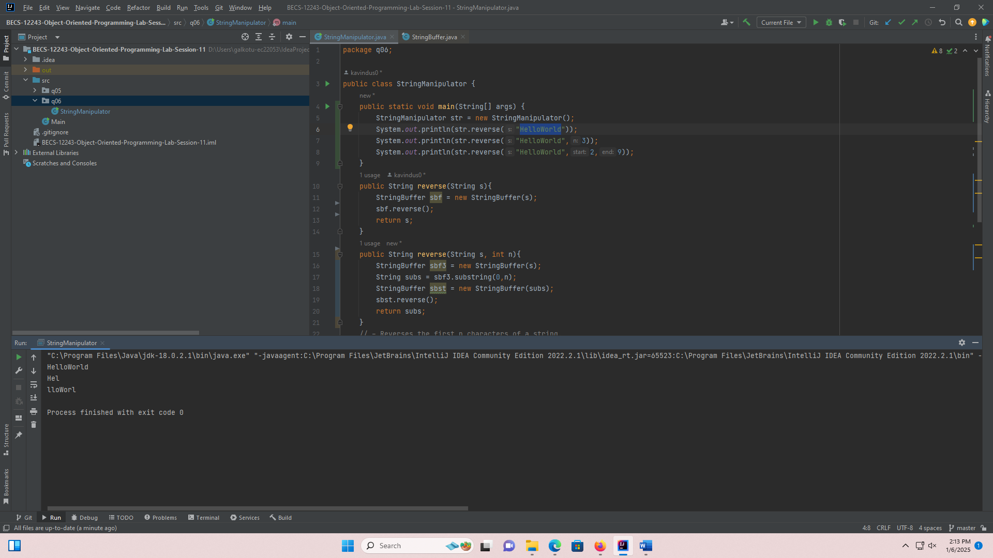 return subs;

}

}